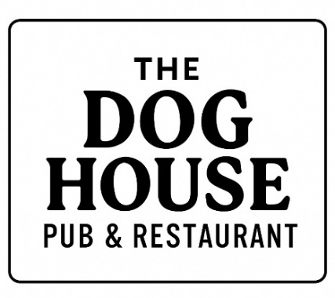
Lunch for £9 or less

Sandwich, wrap or roll
£6
Egg mayo, Tuna mayo, Ham, Cheese, Fish goujon, Chicken goujon, Bacon, Sausage, Chicken Caesar, Fried egg,
sweet chilli chicken
(Served with crisps & salad garnish)
Jacket Potato
£8
Tuna mayo, Cheese and beans, chilli con carne, veg chilli
(Served with salad garnish)
Small cod & chips
£8
Small scampi & chips
£9
Bowl of chips
£3.50
Sweet potato fries
£4
Onion rings
£3.50

**Any allergens please state at time of order

